**STATS 401 Lab 8 Exercises**

**Exercise 1:**

In Task2, try to set your shape by

(1) filling in none,

(2) stroke to be black,

(3) setting the stroke-width parameter to be 1.

So it looks like this:

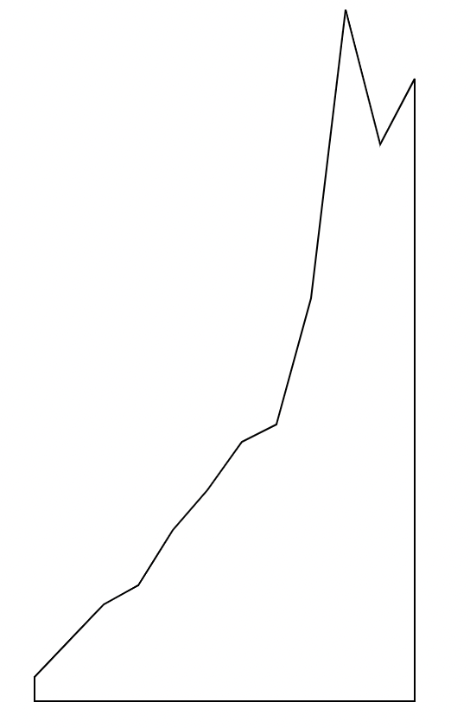

**Exercise 2:**

Find a sample area chart online and add x and y axises for it, and regenerate it using D3 codes! It’s totally fine if you cannot get the precise data, feel free to make up the data points yourself.

After you finish, please zip all files and submit the zipped folder to Sakai.